# Detailed Simulation Results

In the following Figure X, the complete circuit diagram can be seen.

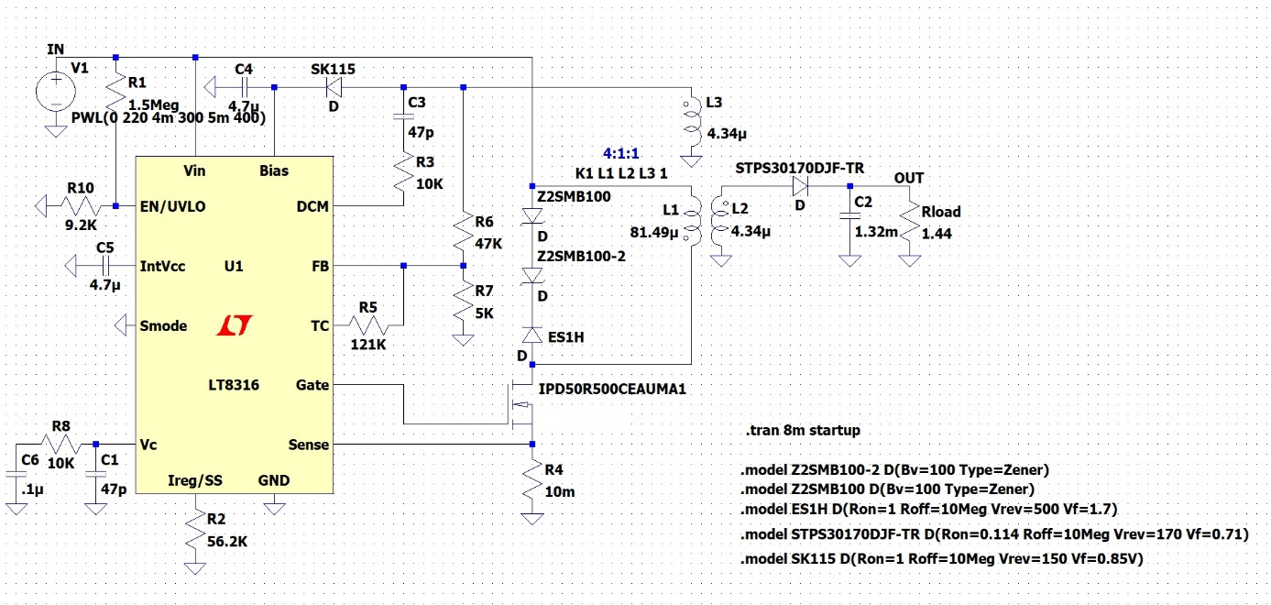

As the project specs indicates that the input voltage can vary between 220V and 400V. The input voltage changing with respect to time is shown in Figure Z. Also, Figure X and Y show that the performance of the output voltage and the output voltage ripple, respectively.

Figure Circuit Diagram

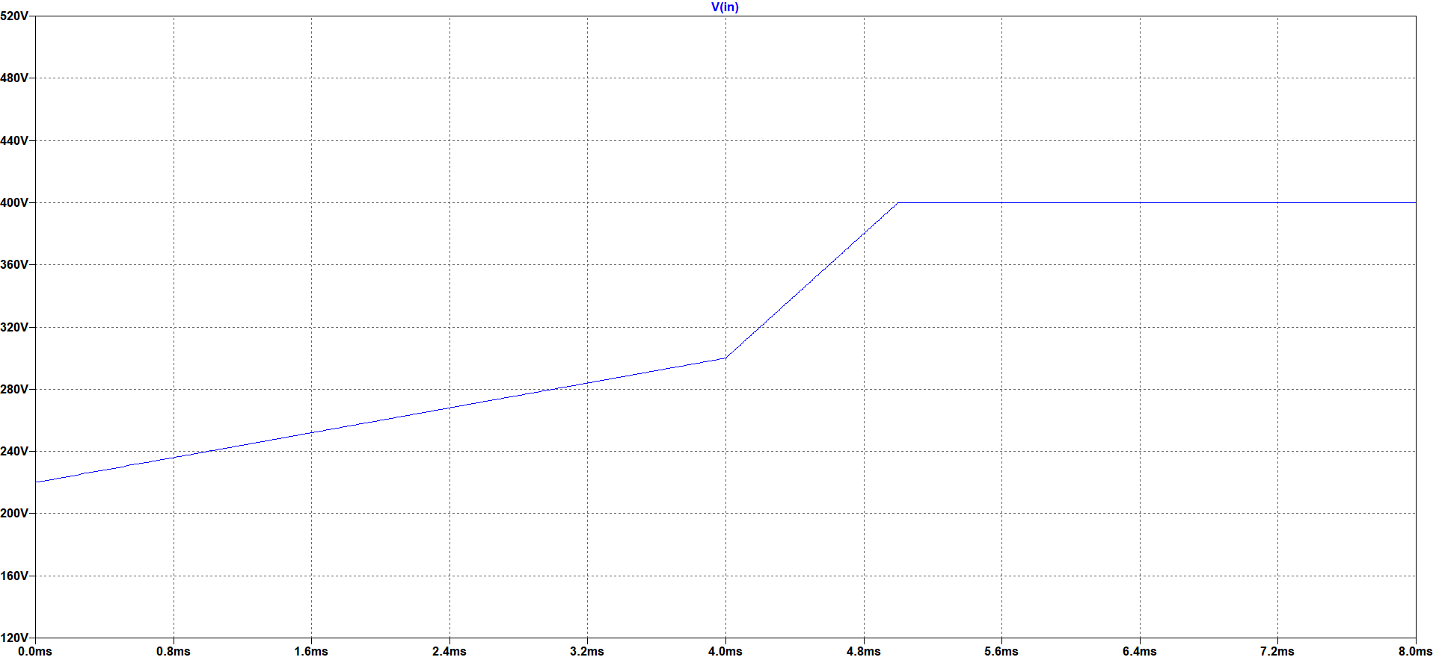

Figure Varying Input Voltage

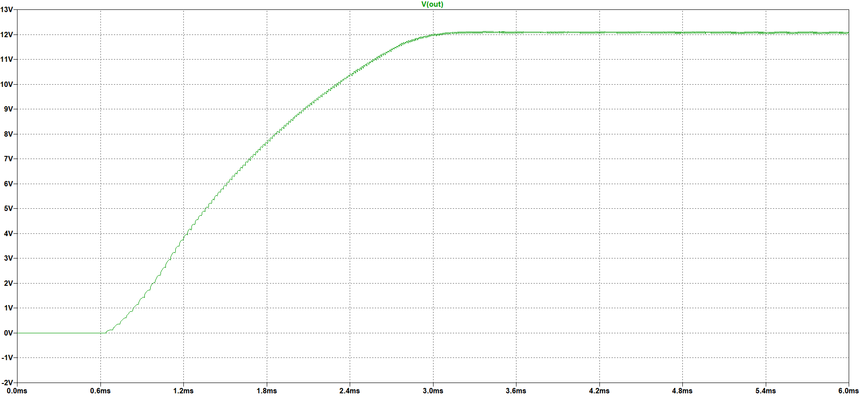

Figure Output Voltage Performance for Varying Input Voltage

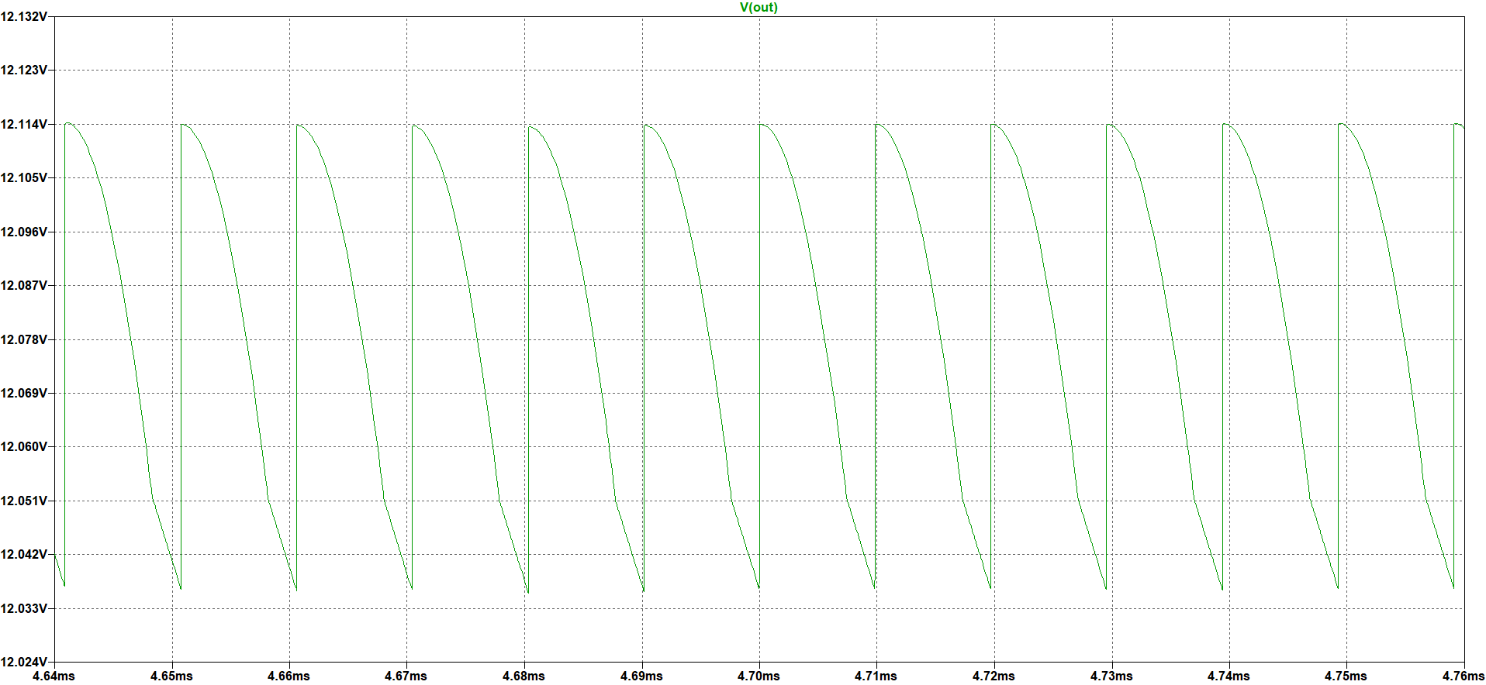

Figure Output Voltage Ripple for Varying Input Voltage

As can be seen in the above figures, the output voltage almost is not affected by the varying input voltage. It can give 12V with a small ripple which is in the specified ripple margin.

The following Figure X shows the output voltage performance. As can be seen in that figure, the controller has a soft start property and the output voltage reaches 12V around 145ms. Since the output voltage reaches 12V almost same time even for the extreme cases, Figure X shows only 220V input voltage situation.

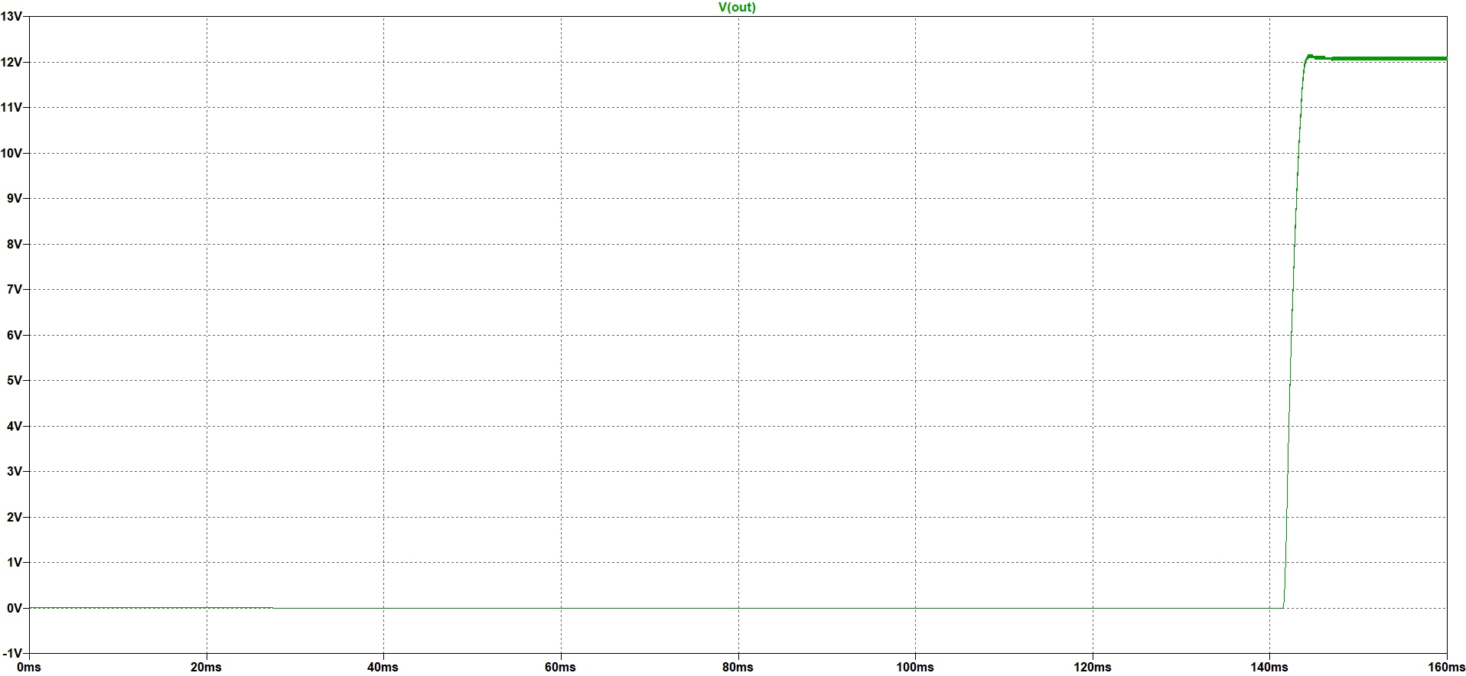

Figure 5 Output Voltage Performance for 220V Input Voltage

After that point, all the voltage and current waveforms are shown for both 220V and 400V input voltage that are the extreme values of the input voltage. Figure X shows the output voltage waveform.

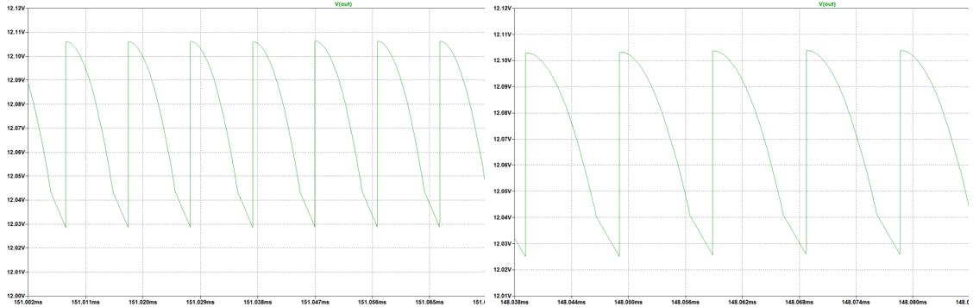

Figure 6 Output Voltage Waveform for 220V (left) and 400V(right) Input Voltage

As can be seen in the above figures, the ripple is almost same for extreme input voltage values and this voltage level is important for output capacitor selection. Also, the current passing through this capacitor which can be seen in the following Figure Y is also important for this selection.

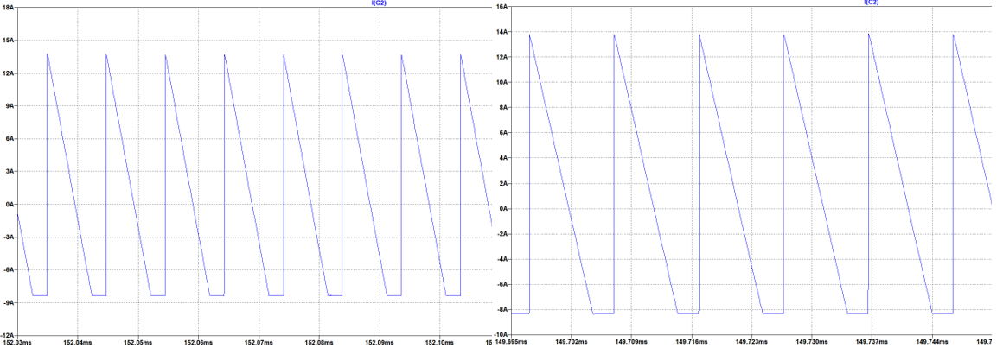

Figure 7 Output Capacitor Current Waveform for 200V (left) and 400V (right) Input Voltage

As can be seen in the above figures, the current ripple on this capacitor is almost 20A. Therefore, the selected capacitor for the output side should filter this ripple. Furthermore, to obey the 4% voltage ripple criterion the ESR value of the selected capacitor must be very small.

The following Figure X and Y shows the output diode current and voltage waveforms, respectively.

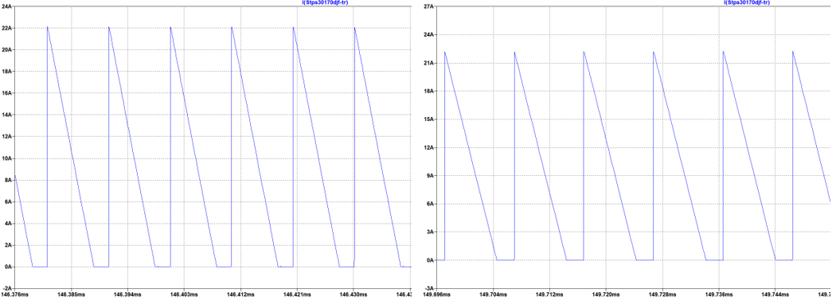

Figure 8 Output Diode Current Waveform for 200V (left) and 400V (right) Input Voltage

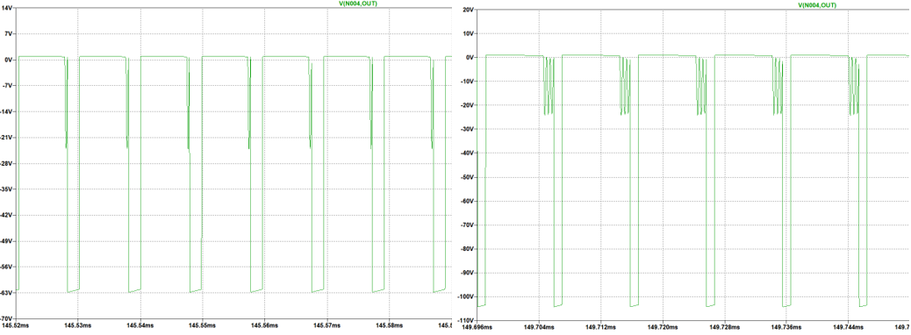

Figure 9 Output Diode Voltage Waveform for 220V (left) and 400V (right) Input Voltage

As can be seen in the above figures, the diode current is almost same for different input voltages and around 22A; however, the reverse voltages on this output diode are not same. When the input voltage is 400V, the diode can withstand almost 110V. These values are important for suitable output diode selection.

The following Figure X and Y shows the MOSFET gate voltage and current waveforms, respectively.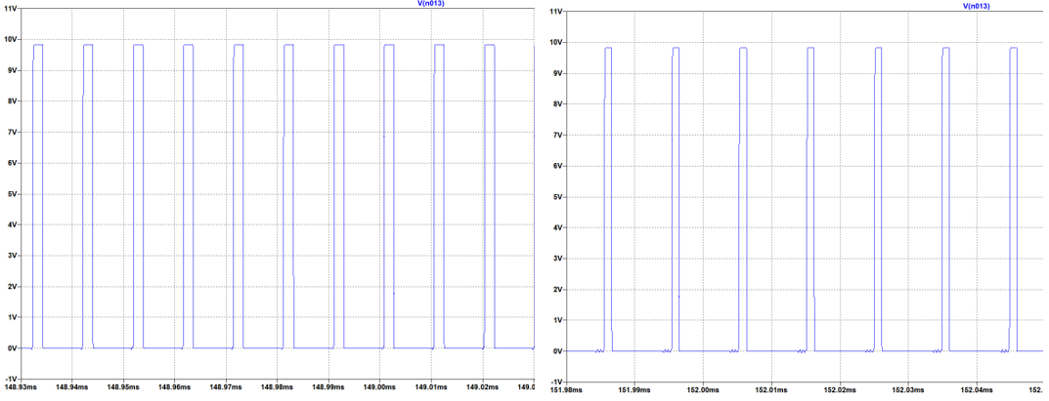

Figure 10 MOSFET Gate Voltage Waveform for 220V (left) and 400V (right) Input Voltage

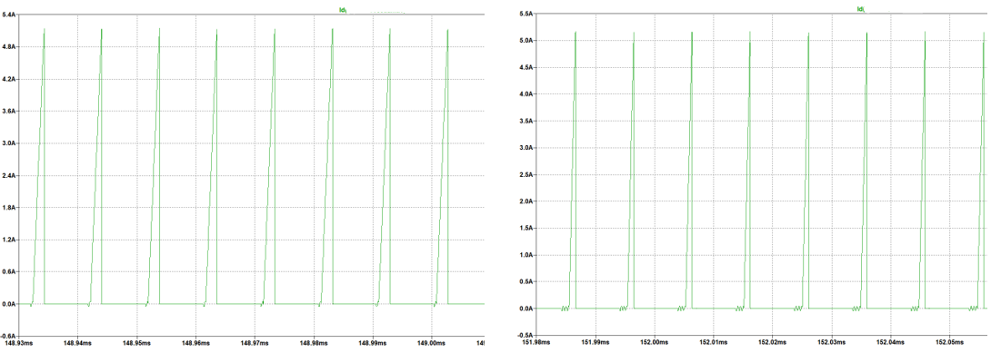

Figure 11 MOSFET Current Waveform for 200V (left)and 400V (right) Input Voltage

As can be seen in the above figures, the gate voltage of the MOSFET is almost same for both cases and around 10V. Moreover, the current waveforms are also similar, and it is around 5.1A. These values are important for suitable MOSFET selection.

In the following Figure X and Y, current and voltage waveforms of the tertiary diode can be seen, respectively.

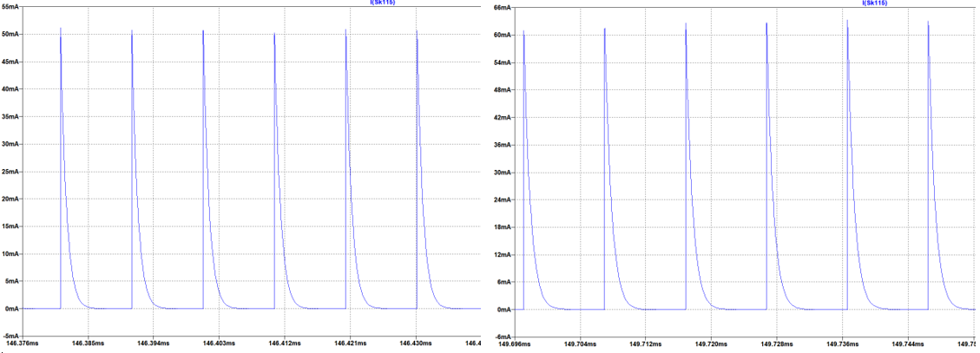

Figure 12 Tertiary Diode Current Waveform for 200V (left) 400V (right) Input Voltage

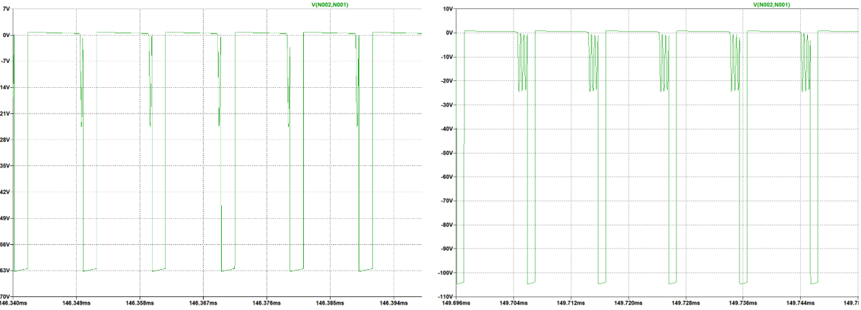

Figure 13 Tertiary Diode Voltage Waveform for 200V (left) and 400V (right) Input Voltage

As can be seen in the above figures, the current varies between 50mA and 60mA; however, for voltage this varying is more obvious. In short, the diode should withstand 110V. These values are important for suitable tertiary diode selection.

In the following Figure X, voltage waveforms of snubber diode can be seen.

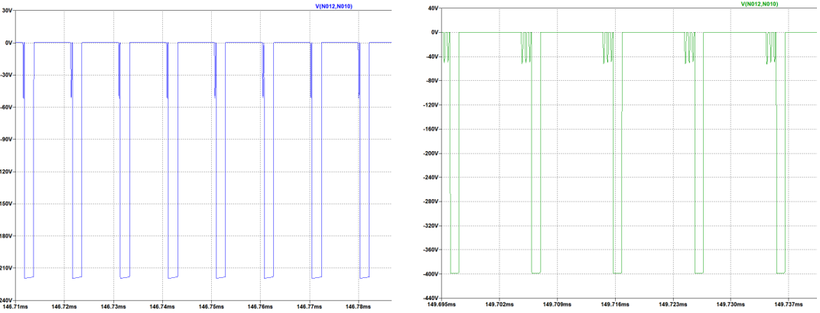

Figure 14 Snubber Diode Voltage Waveform for 200V (left) and 400V (right) Input Voltage

In the following Figure X, voltage waveforms of snubber zener diode can be seen.

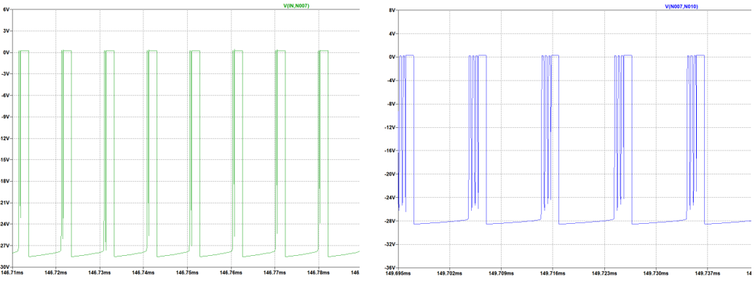

Figure 15 Snubber Zener Diode Voltage Waveform for 200V (left) and 400V(right) Input Voltage

As can be seen in the above figures, while the snubber diode should withstand at least 400V, the zener diodes should withstand only 30V. These values are important for snubber diode selections.